**SMART CLASSROOM**

**Using Calm Technology**

A Project Report Submitted

for the Course

**CS499 Project II**

*By*

**Abhishek Sarkar**

(Roll No. 11010101)

**Kartheek Nagelli**

(Roll No. 11010145)



*to the*

**DEPARTMENT OF CSE**

**INDIAN INSTITUTE OF TECHNOLOGY GUWAHATI**

**GUWAHATI – 781039**

*April, 2015*

**CERTIFICATE**

This is to certify that the work contained in this project report entitled

“**Smart Classroom using Calm Technology**” submitted by **Abhishek**

**Sarkar** and **Kartheek Nagelli** (**Roll No.: 11010101 and 11010145 re-**

**spectively**) to Department of CSE, Indian Institute of Technology Guwahati

towards the requirement of the course CS499 Project II has been carried

out by them under my supervision.

Guwahati - 781 039 (Dr. Samit Bhattacharya)

April 2015 Project Supervisor

**ABSTRACT**

Smart classroom using Calm Technology – is an attempt towards using the plethora of smart devices available so readily to us today and applying them towards the betterment of the classroom experience. We have focussed on android devices because of their ease of availability. We focussed on three major interaction areas that exists at an undergraduate classroom environment. The first one is the process of doubt asking, the second being certain scientific or research oriented keywords in the study materials provided for students, and lastly we have the links citing other resources again from the study material or slides uploaded for the students. We had identified the mentioned factors in the first part of this project. In this part we focus more on their implementation and design aspects associated with such that fall under the domain of calm technology and ubiquitous computing.

**Contents**

1. **Introduction**
2. **The App**
3. **Special Features**
4. **How it Works**
5. **Use of Calm Technology**
6. **Testing**
7. **Conclusion**
8. **Bibliography**
9. **Activity Diagrams**

**Introduction**

Smart classroom using calm technology is a project which tries to use the smart devices available to students do readily today and integrate them into the classroom experience. The most important factor central to our work is to have the least effect on the natural classroom behaviour by the students or the instructor while using this application.

We chose android as our implementation platform for their ready availability and huge developer support from Google. It took us around three weeks to successfully learn the development procedures and languages required for android development. After this we researched various design principles that fall under calm and ubiquitous computing. Most of our design principles are based on the findings as given in [2] and [3]. This took us about 4 days to complete.

After this came the actual software design phase. We started off with making pencil sketches of how each screen will look like and how each activity involved will interact with one another. Then we formally designed each part in the form of activity diagrams (included at the end). This took us about a week.

Finally we started the development process which took us about a month to complete.

**The App**

Below we have attached the various screens one may encounter while using the application.

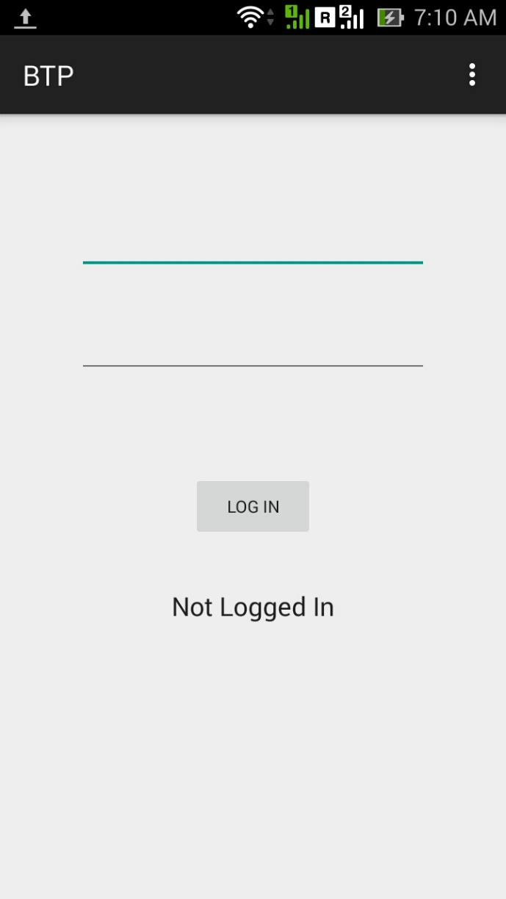 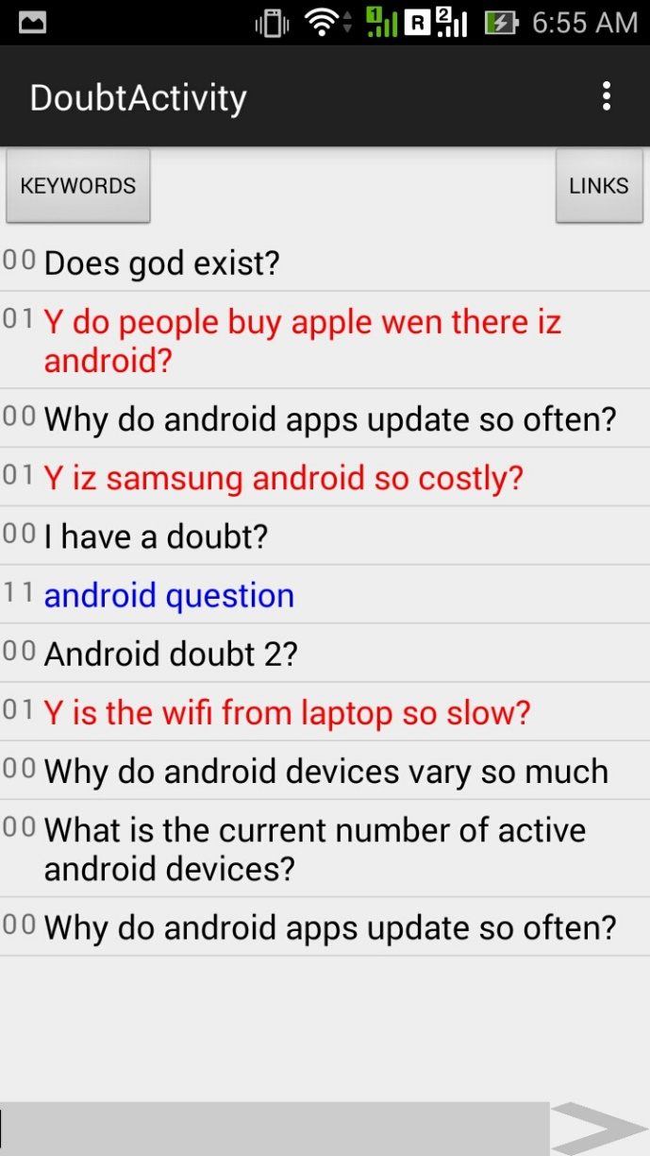

*Figure 1 Figure 2*

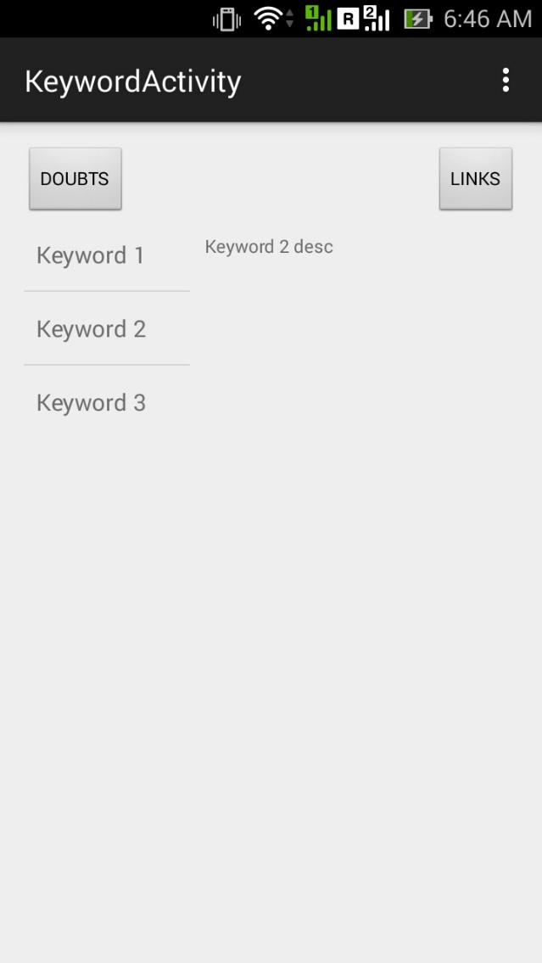 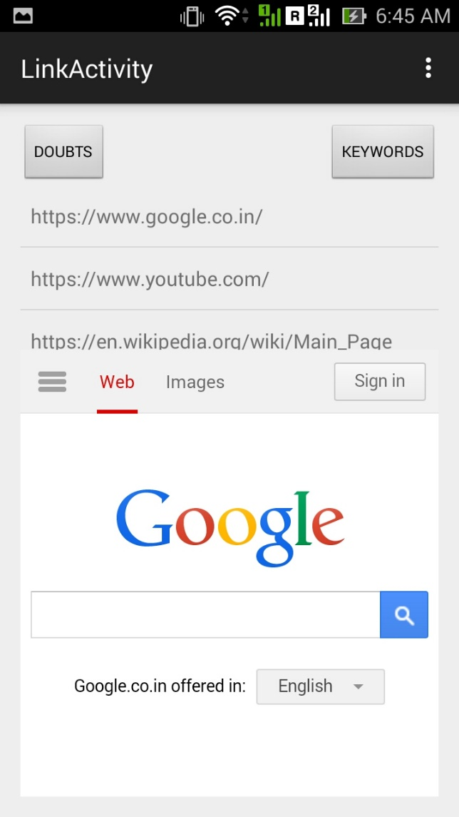

*Figure 3 Figure 4*

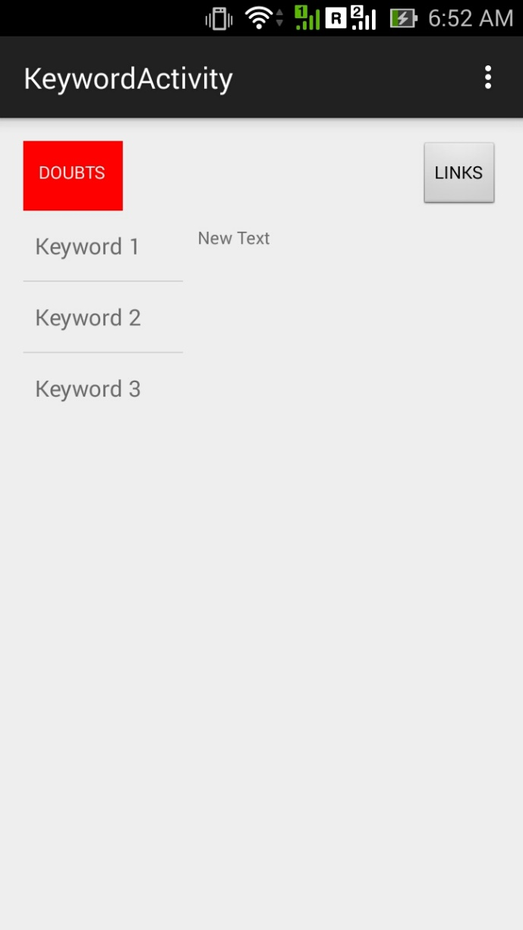

*Figure 5*

*Figure 1* is the very first screen that the user(student) will be presented with any device for the very first time. His account must already exist in the database. We have not included the feature for signing up for a new account yet as it did not help in the final goals of this project.

Once he/she logs in, if this is the first time he/she is using this device and application *Figure 2* will be what he/she sees. If not, he/she may see any of the screens from among *Figure 3*, *Figure 4* and *Figure 5* depending on the various states of the application accessed and used. If the user has more than one device the buttons on top of each activity will be invisible depending on which activities the user has opened. For full details please refer to the activity diagrams at the end of this report.

**Special Features**

The application is designed in such a way that it can fully exploit the availability of more than one smart device with a single user. Any of the screens above can be opened in different devices in parallel and they will still perform as if a single device was being operated.

The application also is totally dynamic – it updates changes on the flow without the user having to do anything.

**How it works**

To keep all the devices in sync across all different users we have used a central server system to coordinate them all. This idea is very similar to the one described in [4].

We installed a server on a laptop and connected all devices on to its wireless network. All devices then periodically create logs into the database server which in turn are used to determine what content is to be served by which device to which user.

For example in *Figure 5* above we see the ‘Doubt’ button having a background colour of red, however in *Figures 3* and *4* it is not so. What has happened here is that while a user was on the screen for Keywords some other user had performed some interaction in the doubt screen. As a result there were changes in the database. Now when this user’s device sees this change it informs its user of such change by highlighting the doubt button.

Interactions like this happen periodically across all activities in the background to reduce the users interaction in actions which are unrelated to his studies.

**Use of Calm Technology**

We have used features of calm technology extensively in the design process to give the user a better experience.

1. **Device Positioning**

The device positioning of each device makes a lot of difference to the user experience. [2] describes and categorises and quantifies performance metrics in the various scenarios possible in multiple device user interfaces. According to [2] the factors affecting visual attention switch include if kinds of display devices the user has are contiguous (Display contiguity), which again branches out into *visual field contiguity* and *depth contiguity*. Another type can be the display devices are discontiguous (*Visual Field and Depth Discontiguity*). According to the summarization chart in [2] ubiquitous graphics is possible for devices which together are *Depth Incontiguous* and *Visual Field Contiguous*.

What it means is that the multiple devices that a user chooses must be placed close to one another (*visual field contiguous*) while they should be placed at different distances from the user(*depth discontiguous*).

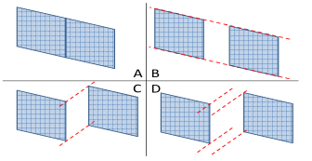

In the above Figure

*A – Depth and Field Contiguous*

*B – Depth contiguous and Visual Field discontiguous*

*C – Depth discontiguous and Visual Field Contiguous*

*D – Deth and Field Discontiguous*

So according to above study we would suggest the positioning of devices in order C for the best ubiquitous experience.

1. **Layout Design**

We designed our layout to conform with the results found and discussed in [3]. [3] is a study on television screens which take images into account as well. However in their study they have included the case when the number of images is zero. We can use the result of those studies in our work.

What [3] derives finally are the following:

1. In the absence of images the cognitive ability of a user is not affected by the length of the text displayed.
2. In the absence of images the stress on the users psych is less for shorter text.
3. In the absence of images smaller texts are understood faster than larger ones. This however reverses when images are present, i.e. in the presence of images larger texts are understood faster by users.
4. In the absence of images the total work load on the users mind is always less for smaller texts.

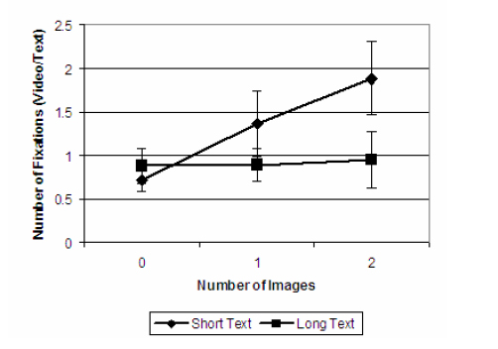

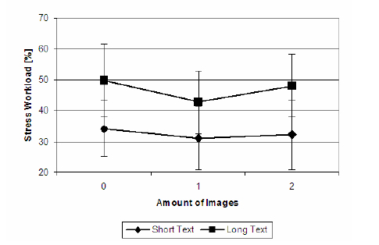

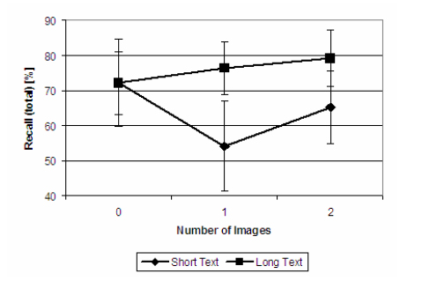

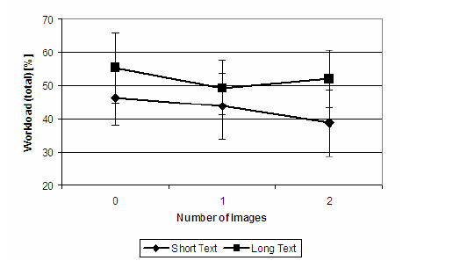

The graphs above are directly taken from [3].

As per the above results we have made it a point to get our information across to the users in as little text as possible. This is possible for the keywords section as we have some level of control over it. However for the doubts and links it solely depends on the users. We hence encourage our users to put in shortened links into slides whenever possible and also ask doubts as concisely as possible. In the doubts section we have kept the display of up votes and down votes to the minimum as well.

1. **Notification System**

We chose to use red colour because of its lowest speed among all others in the colour spectrum. What it means for the user is that the colour is most noticeable and does not lose its property with distance. This probably does not matter for such short distances but we chose it anyway. The colour also has the property of giving the user a feeling of closeness compared to other colours, which will help with depth discontiguity. As of now the notification system only for detecting changes in doubts is active.

**Testing**

For testing the application we used 6 android devices taken from friends and ran them simultaneously at different stages of application run. We also created 2 user accounts initially for testing purposes.

The links and the keywords and their descriptions were hard-coded into the devices because the parsing phase for the pdfs or slides did not really affect our results in any way.

The application ran successfully in all scenarios as expected. The most noticeable flaws being :

1. The application is very slow. This is mostly because of the huge amount of queries being executed by our application, the quality of the wireless network provided by the laptop and also the fact that the server was not run a dedicated machine. Possible solutions can include the usage of web sockets instead of periodically pining the database for information.
2. There were problems holding and maintaining the device at discontigous lengths from ourselves. Maybe a crafted holding device instead of our hands can overcome this problem.
3. Sometimes when more number of users used the database together some queries were executed in different orders. This is actually entirely because of the fact that the server was being run windows via wamp, through which mysql can only create so many threads of execution. On a dedicated server these problems should not occur.

Apart from the above flaws the application performed mostly as expected.

**Conclusion**

The project as it stands now is a system that uses several features of calm technology and ubiquitous computing to provide the user (students) with a better classroom experience. Although not a complete working system yet further work can be done right on top of this for a much enhanced result.

Some of the future work that may be possible are :

Firstly the system is incomplete as of now. The interface for the instructors is still left. We have solely focussed on the interface for the students and the android side of the project. Since we are using a server any language really can be used on the client side to communicate with the server. It does not necessarily have to be in android, or a web interface, or a .net application - it can be any of them.

And to process of pinging periodically can get taxing on some older devices and on the database as well. So if the entire process can be done using socket programming the overall communication process should become much polished at least between the server and client.

For improving the database communication and the resulting lag, a dedicated server would be the best solution.

The activity diagrams are included after the Bibliography section.

**Bibliography**

[1] Radu-Daniel Vatavu and Matei Mancas. 2014. Visual attention measures for multi-screen TV. In Proceedings of the 2014 ACM international conference on Interactive experiences for TV and online video (TVX '14). ACM, New York, NY, USA, 111-118.

[2] Umar Rashid, Miguel A. Nacenta, and Aaron Quigley. 2012. Factors influencing visual attention switch in multi-display user interfaces: a survey. In Proceedings of the 2012 International Symposium on Pervasive Displays (PerDis '12). ACM, New York, NY, USA, Article 1 , 6 pages.

[3] Jan Kallenbach, Silja Narhi, and Pirkko Oittinen. 2007. Effects of extra information on TV viewers' visual attention, message processing ability, and cognitive workload.

[4] Roberto Martinez-Maldonado, Yannis Dimitriadis, Andrew Clayphan, Juan A. Mu˜ noz Cristóbal, Luis P. Prieto, Mar´ıa Jesús Rodr´ıguez-Triana, and Judy Kay. Integrating orchestration of ubiquitous and pervasive learning environments. In Proceedings of the 25th Australian Computer- Human Interaction Conference: Augmentation, Application, Innovation, Collaboration, OzCHI ’13, pages 189–192, New York, NY, USA, 2013. ACM

**Activity Diagrams**

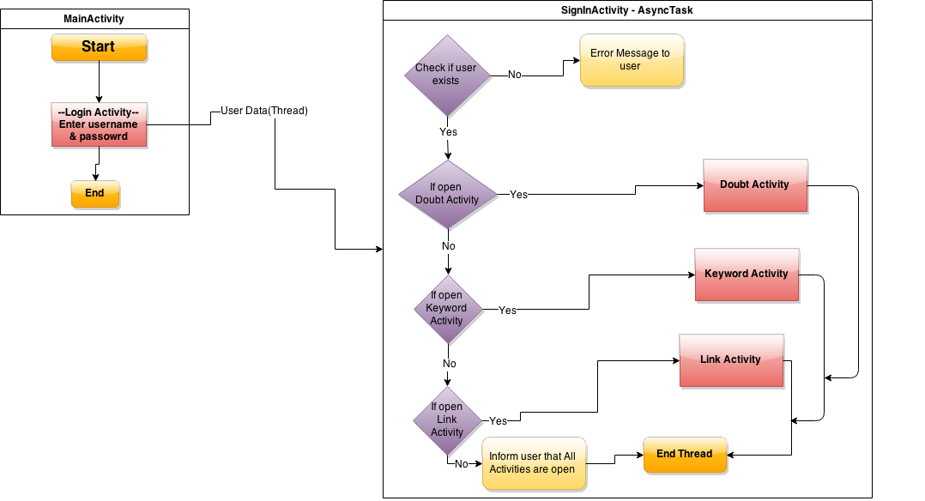

***Main Activity***

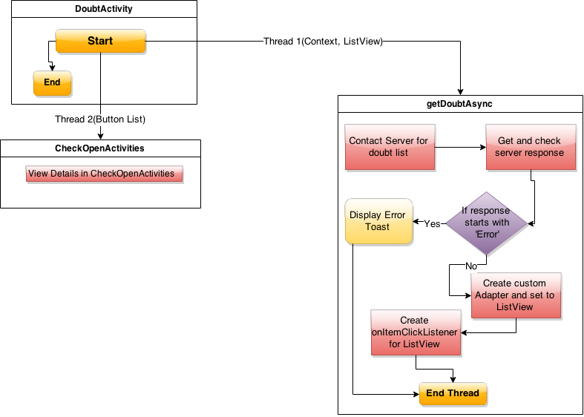

***Doubt Activity***

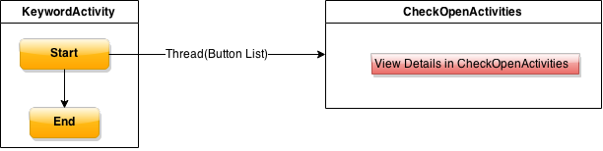

***Keyword Activity***

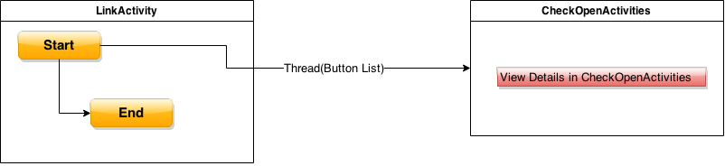

***Link Activity***

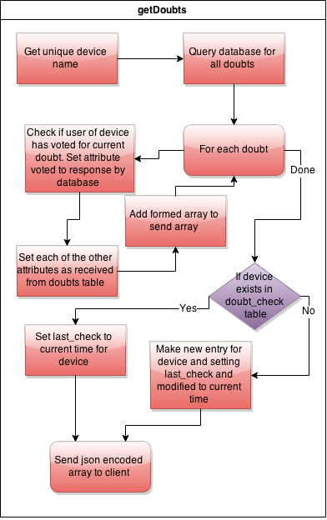

***getDoubts – Server Side***

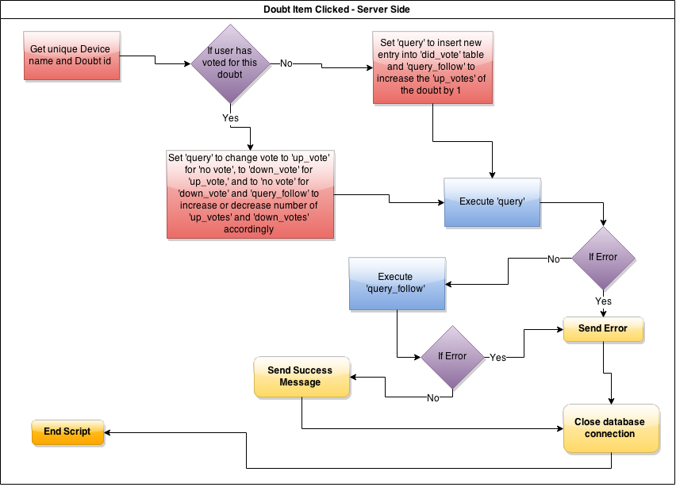

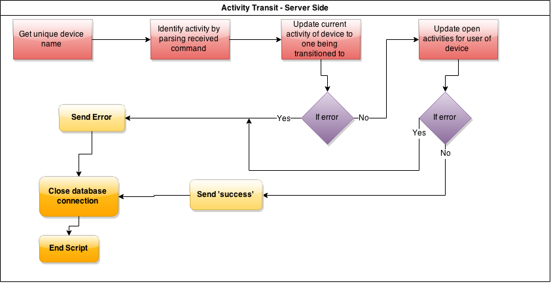

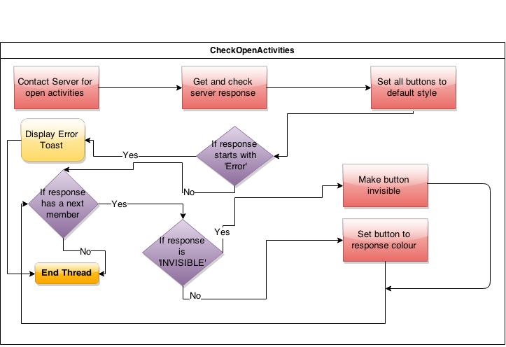

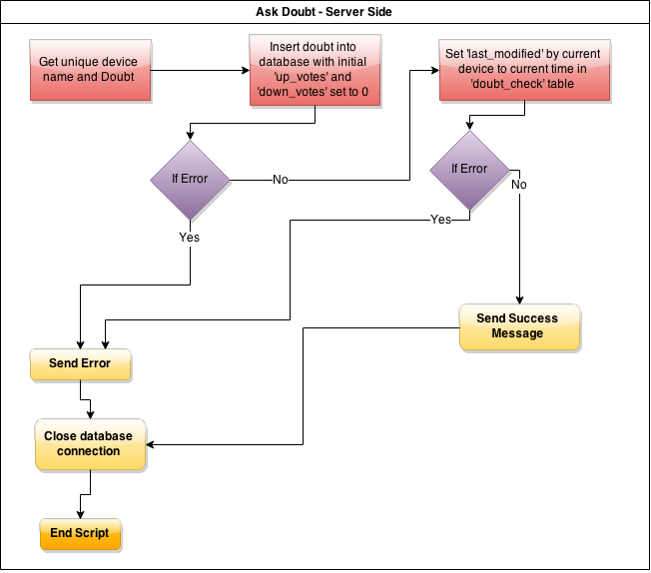

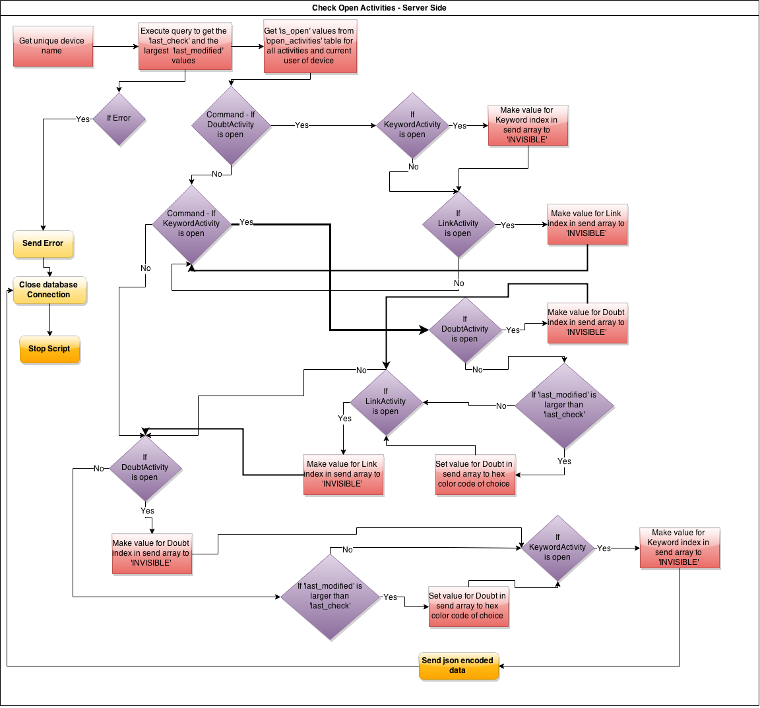

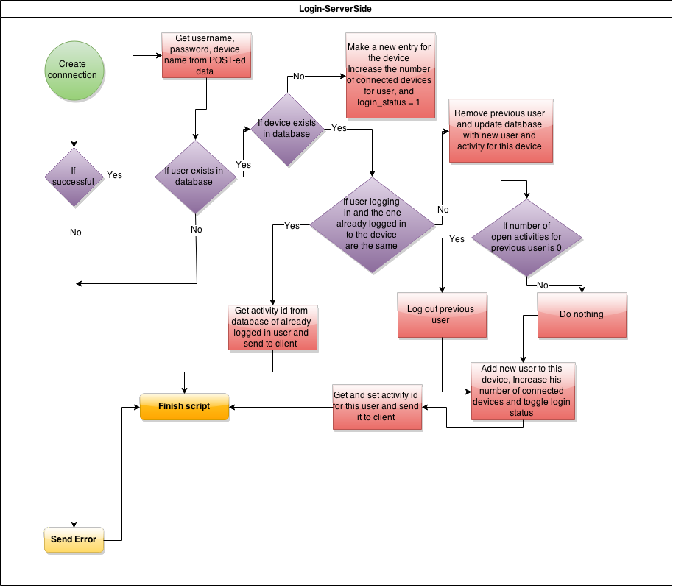

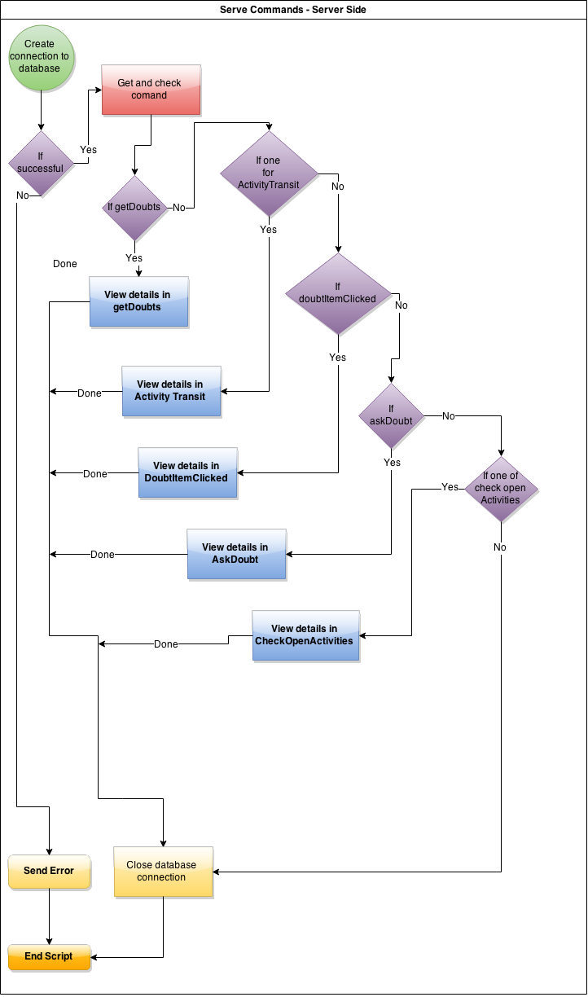

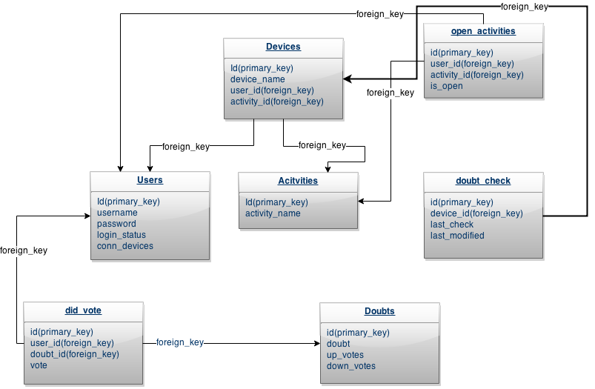

***Database Structure***